**Identification of Sister cities based on Pollution Data**

[**Paper-1**](https://www.mdpi.com/2073-4433/13/3/494) **: Classification of Urban Pollution Levels Based on Clustering and Spatial Statistics (Published 19 March 2022)**

Data:

* China (86 cities)
* Jan 1 2008 to 31 Dec 2012 (4 yrs)
* Source : Environment protection board
* Air pollution index and SO, NO and PM
* Might need Interpolation because data is not evenly spaced

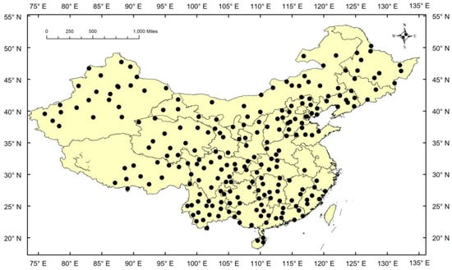

Figure 1 : Data Availability

* Performed systematic cluster analysis on the research data (Hierarchical clustering) after normalising
* Cities were clustered into 4 categories: slightly polluted good excellent and polluted
* Main Pollutants considered for clustering: SO, NO and PM
* After clustering Hypothesis was: **PM less at costal regions as it receives more rainfall and are easily blown away by wind as compared to inland regions**
* Data for some major cities weren’t available so they performed kriging interpolation adopted using ArcGIS.
* First level clustering was done for capital cities .

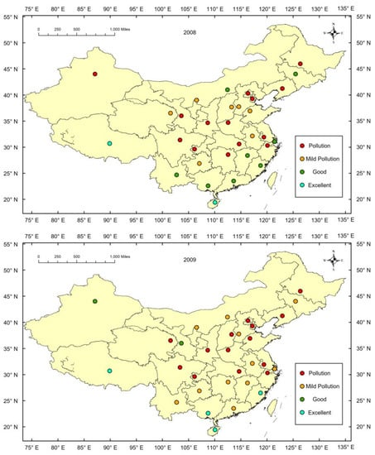

Figure 2: Classification for 2012 data

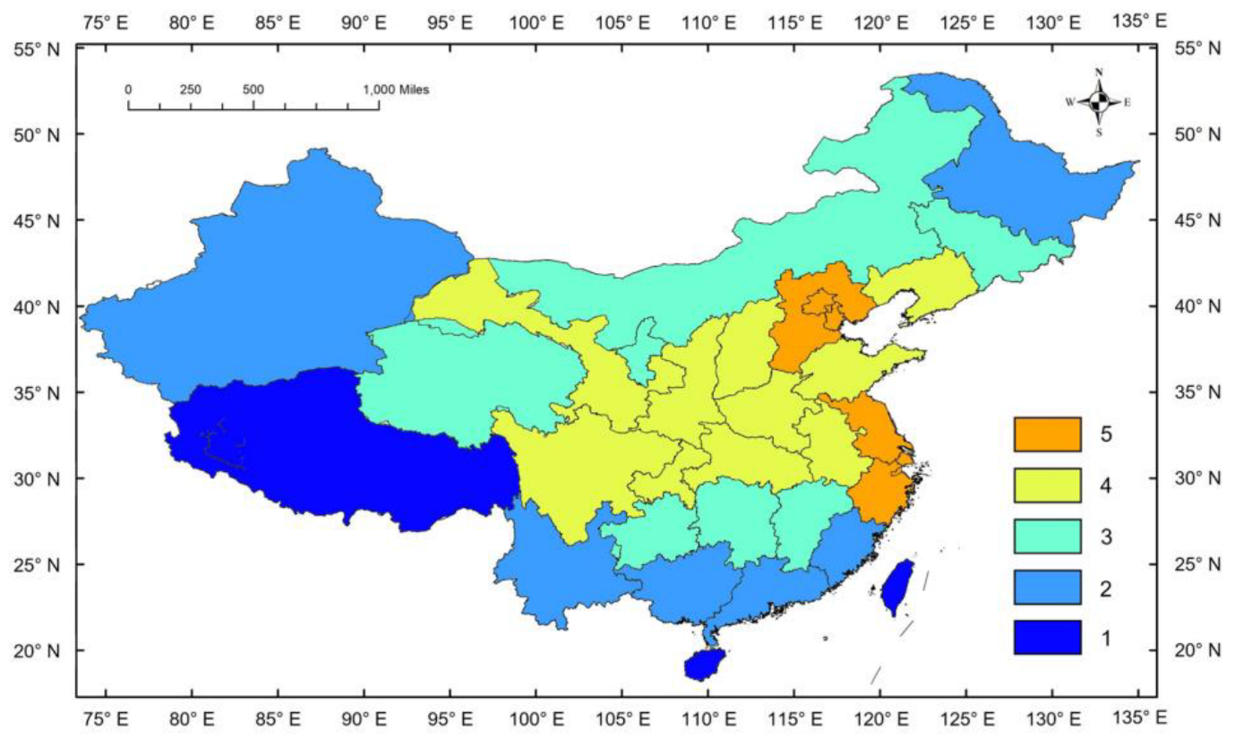

Figure 3 : Divided China into **31 cities** and sister cities considering results of all 4 years

[**Paper - 2**](https://www.mdpi.com/2073-4433/13/4/503) **:Malaysia PM10 Air Quality Time Series Clustering Based on Dynamic Time Warping**

* Clustered on basis of similarity in Time Series
* Malaysia : 2017 July - 31 Jan 2019 (only pm10)
* Published in 2022
* Idea : Perform **Shape Based clustering**
* DTW – Dynamic Time Warping
* Warping : Distance measure b/w two time-series
* Shape Based Distance – Dissimilarity measure can be used
* Common Clustering Techniques to try: K-Means, Hierarchical clustering, **Partition around Medoid**, Fuzzy K-means
* Imputation (missing values) done using linear interpolation methods
* **Prefer Hierarchical clustering** as it groups smaller number of members for formation of clusters with contrary patterns, such as outliers. But K-means tries to create clusters of similar sizes
* Created 4 clusters: Urban, Industrial, Sub-Urban, Rural ( Government Results)
* Government classification is used as ground truth and rand index was calculated

[**Paper -3**](https://www.sciencedirect.com/science/article/pii/S095741742031157X?via%3Dihub) **: Multi-hour and multi-site air quality index forecasting in Beijing using CNN, LSTM, CNN-LSTM, and spatiotemporal clustering**

**Data :**

* Air quality at Beijing (Rough range for and Idea : 20-400)
* AQI is most commonly used Index. It mainly comprises of the following pollutants: CO NO2 O3 PM10 PM2.5
* 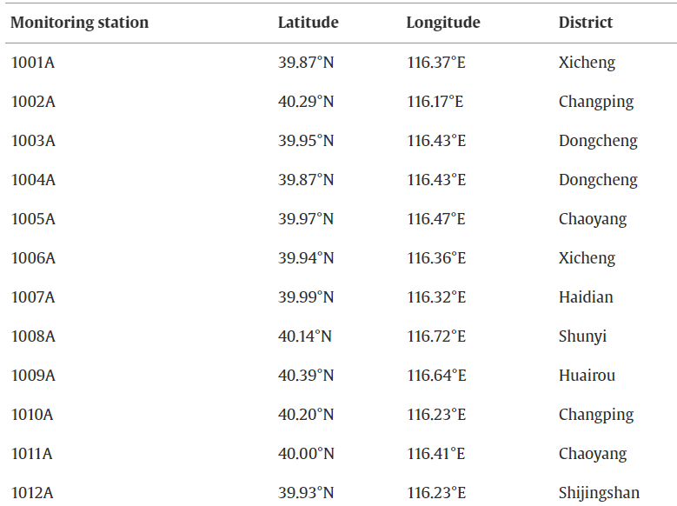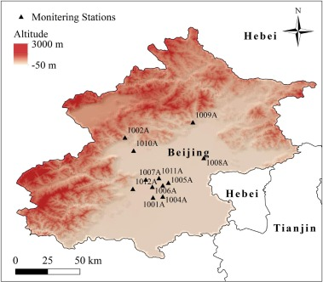Data from 12 stations in Beijing (Jan1st-2015 to Dec31st-2016)

**DATA USED**

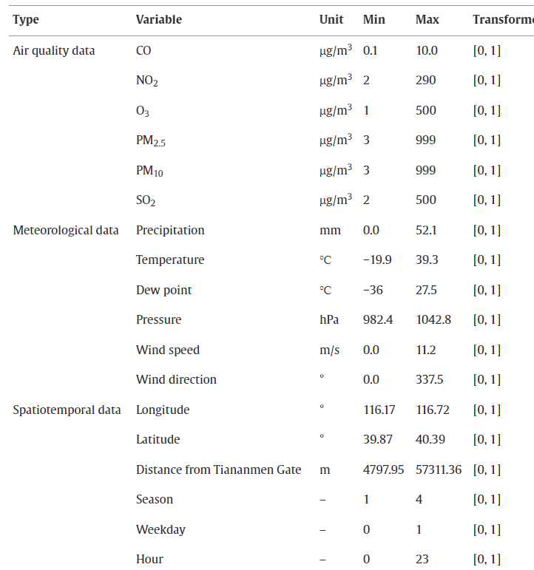

**Geography:**

* Beijing is surrounded by hills in north and west.
* Beijing has short springs and autumns, hot and rainy summers and cold and dry winters
* Beijing also has a lot of industrial cities

**Methodology:**

* Missing Values:
  + Each site has less than 5% missing data
  + Mean value of pollutant data from other sites at same time was used to fill the gap (why??)

“As some variables had missing data at individual sites at a certain time, the mean value of the data from other sites at the same time was used instead”

* + If the value was missing at all sites, mean value of data available before and after missing gap were used to fill NaN’s.
* Standardization: Min-Max scaling is done to increase model convergence.
* Interpolation: Ordinary Kriging interpolation technique was used to estimate the value at unknown points.
* Moran I statistics: Gives us an idea of spatial correlation b/w data points. (0.42 on their data)

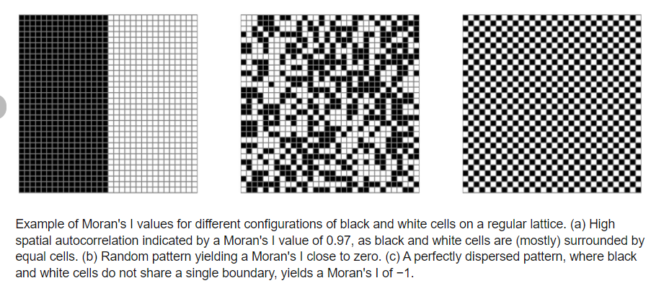

* Clustering : They performed **Hierarchical clustering** with distance measure as Euclidean distance and Wards Linkage Method

Note: Wards method merges 2 clusters with min increase in variance

**Observations:**

* 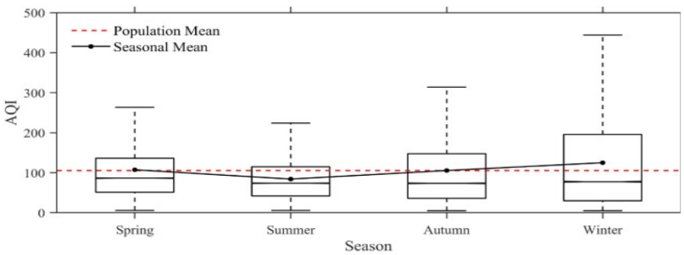The mean AQI increases as :
  + Summer (Jun-Aug)
  + Spring (March-May)
  + Autumn (Sept-Nov)
  + Winter (Dec-Feb)
* Moran-I statistics value was 0.42 ==> There is spatial agglomeration and clustering can be done
* Central Part of China had most pollution
* Regions at North West at high altitudes had lesser AQI

**AQI Forecasting Models:**

* BPNN, CNN, LSTM and CNN-LSTM is used for forecasting AQI
* For Next Hour: CNN-LSTM has least RMSE (best model)
* For Multi Hour:
  + All models tend to perform bad as ΔT increases
  + Difference in RMSE reduces for validation set
  + Accuracy of LSTM’s is the highest however the validation error difference b/w LSTM and LSTM-CNN model is small.

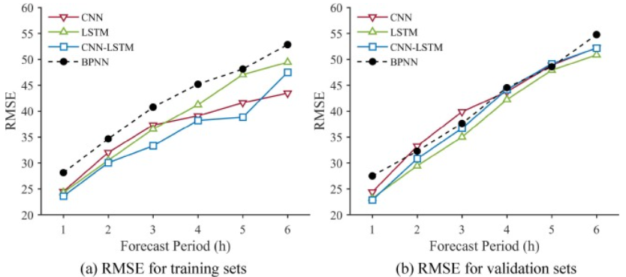

Figure 4 : Modelled without clustering

**Seasonal Clustering:**

* For Seasonal variation the data was clustered into 4 seasons and were modelled using: BPNN LSTM CNN and LSTM-CNN
* LSTM-CNN seems to perform best until ΔT<5hrs

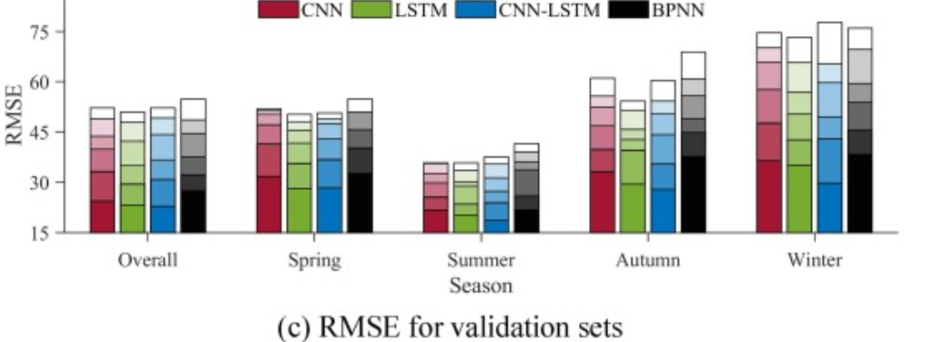

* Seasonal forecasting may not always help: Reduced amount of data may lead to diminishing data patterns

“

Seasonal forecasting may not always effectively improve forecasting accuracy. The reduced amount of data in different seasons cause the deceasing data patterns for model development, which may limit the ability of the seasonal forecasting. Considering the AQI's annual characteristics, it is found that the forecasting error may be related to the AQI levels and the discrete degrees in different seasons. The higher the AQI level, the greater the discrete degrees, the higher the uncertainty of pollution change, and the more difficult the air quality forecasting

”

**Spatial Clustering based forecasting:**

Clusters created using hierarchical characteristics. (k=2)

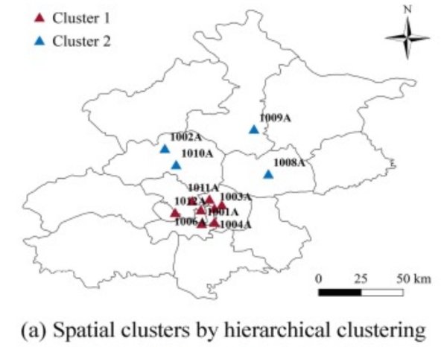

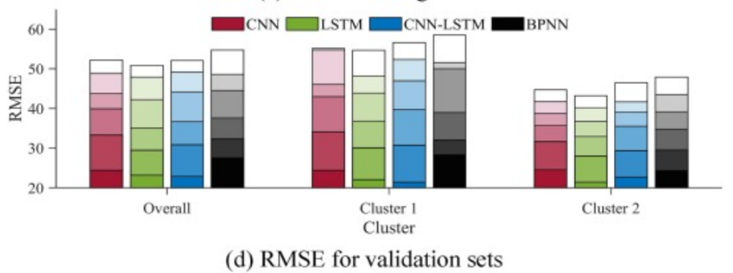

* Performance of cluster 2 is better than cluster 1. Reason maybe because of larger fluctuations in AQI values in cluster 1.

“The poorer performance of cluster 1 than cluster 2 forecasting may be for multiple reasons. The AQI in cluster 1 is generally higher with larger fluctuations, which may cause the forecasting models to underestimate high values or overestimate low values.

Also, the distances between these stations in cluster 1 are shorter, resulting in a smaller AQI difference and stronger spatial autocorrelation. The forecasting difficulty of spatial variation characteristics in cluster 1 is relatively low. “

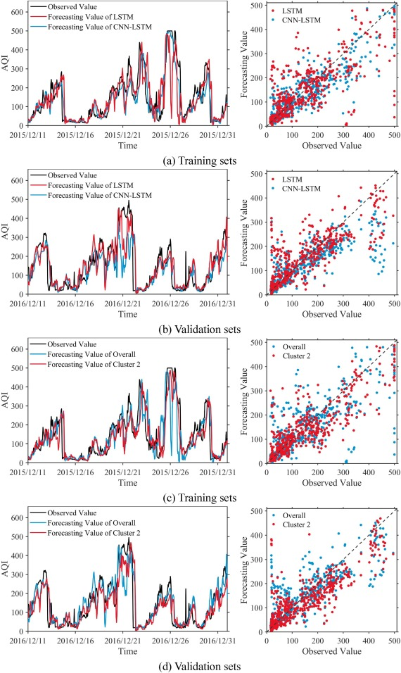

Figure 5: Results for cluster 2

**Conclusions:**

* CNN-LSTM and LSTM were suitable models for single hour and multi hour forecasting respectively
* Spatiotemporal clustering and model combination can improve performance in spatial-temporal data forecasting.
* Ability of CNN-LSTM to generalise and forecast AQI for multiple hours or multiple days reduces . Thus, LSTM outperforms when ΔTforecasting increases.

**Future Work:**

* **Spatial + Temporal clustering not explored yet**

**Paper 4: A multi-variate time series clustering approach based on intermediate fusion: A case study in air pollution data imputation** (Published dec 2021)

Most papers use AQI to cluster. Here they use individual pollutant value to cluster and try to give better measure for AQI.

**Introduction:**

* Stations in UK are categorised as rural, urban, suburban background, roadside or industrial (by UK government)
* Daily Air Quality index is measured using : NO2, O3, PM2.5,PM10­
* Higher DAQI ===> Poor Air Quality (Range: 1-10)
* A lot of missing values can be seen due to instrument down time and calculations of DAQI has a lot of uncertainties

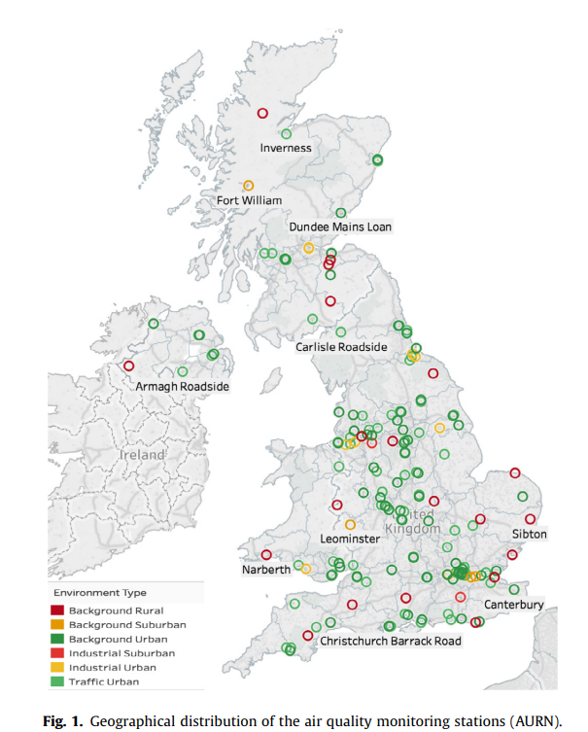

**Methodology:**

* Imputing Missing values at early stages allow us to find similarity measure b/w timeseries

Used **MICE** – Multiple Imputation by Chained eqn’s (Iterative Imputer)

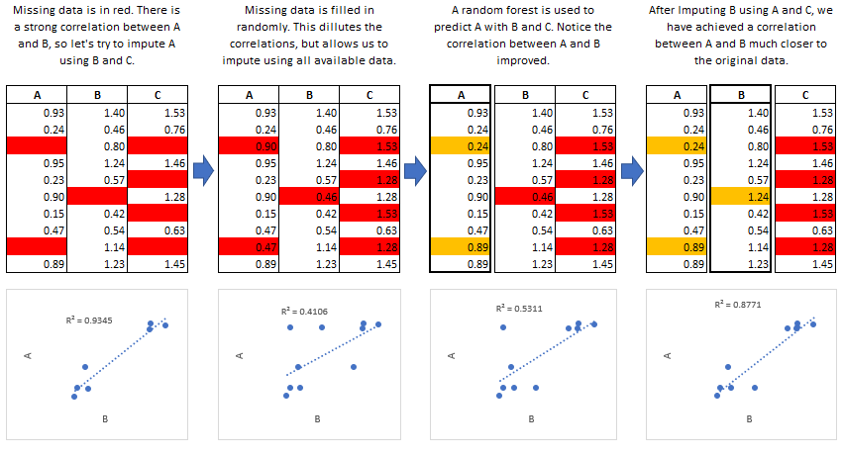

Figure 6 : Working of MICE Imputation

* Similarity Measures: SBD vs DTW, Claim is **SBD** gave well separated clusters and then performed k-Medoids (PAM Clustering) and impute missing values using cluster average imputation method
* We have multiple pollutants, so we have to create a **fused distance metrics**. We take an average of all 4 distances (PM2.5 PM10 O3 NO2) as the distance measure for clustering
* No ground truth to compare clustering solution : So internal quantities like : (but we have station environment data??)
  + - **Compactness**
    - **Separation**
    - **Connectedness**

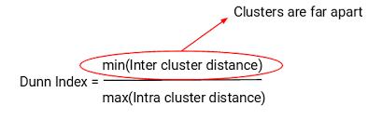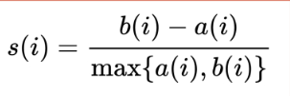 **Silhouette score** and **Dunn Index** are used to measure the above properties (how well separated are clusters)

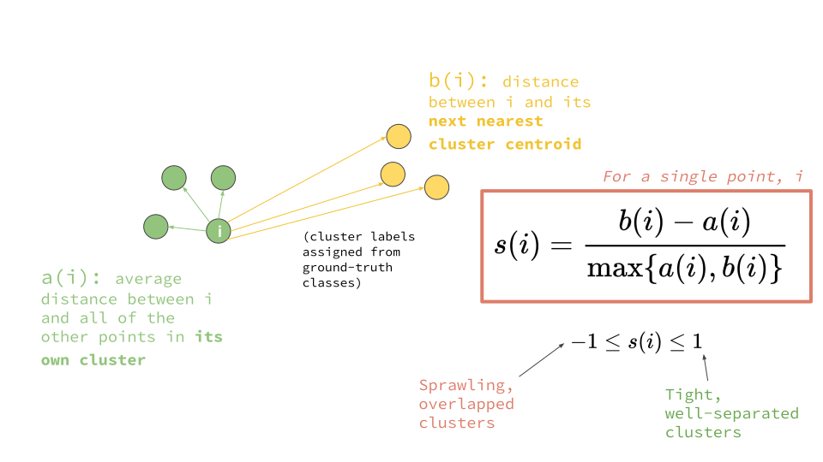

* Two ways of Imputations after Clustering:
  + Cluster Average
  + Cluster Average with Similar Environment: (Rural, Urban, Traffic, Industrial info is available)

**Case 1: Pollutant wise**

* We are clustering stations based on pollutants.
* Two stations can be in different cluster for different pollutants
* SBD to measure similarity of two timeseries given a pollutant

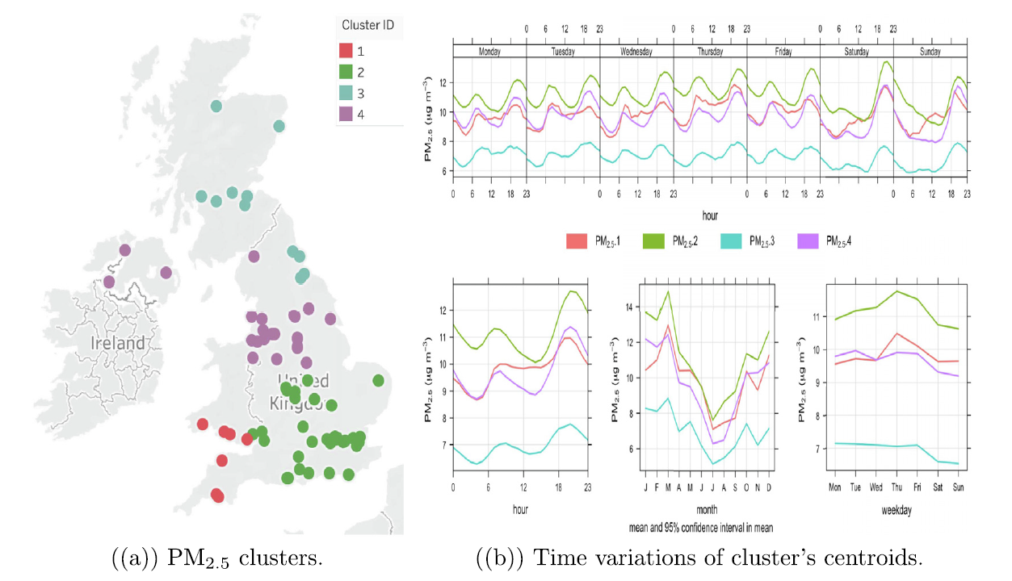

* Results there for all pollutants (PM10 O3 NO2 )

CA – Cluster Average | CA+ENV – Clustering Average + Environment

* There are two ways to impute (CA or CA+Env)
* **Lowest RMSE for: CA -->PM2.5 and PM10 and CA+Env--> O3 NO2**
* **Implies PM not dependent on type of environment and is uniformly dispersed in air, unlike O3 and NO2.**
* ­Since PM have more regional pattern and wider distribution, clustering helps in predicting them more accurately

**Case 2: Clustering Stations (Fused Distance Measure)**

* We find similarity measure using SBD b/w stations for all pollutants and create a fused distance matrix by taking a mean
* We use all stations for clustering

**Case 3: Dropping some stations and clustering stations**

* We used fused distance matrix here too!
* But some stations only measure NO2 . So we dropped those stations .

**Results for Case 2 and Case 3:**

As expected best results for following pollutants:

1. PM’s 🡪 Experiment 3 (dropping stations that measure only NO2 ) + CA for filling missing values as PM have more regional patterns
2. O3 🡪 Experiment 3 + (CA+ENV)
3. NO2 🡪 Experiment 2 + (CA+ENV)

**Data :**

We are scraping data from CPCB website. Wanted to see if scraper is working properly.

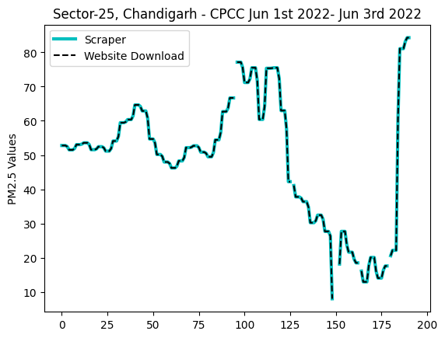**Validation of CPCB Scraper (15 min Resolution)**

1. Sector-25, Chandigarh – CPCC (June 1st to June 3rd 12:00)

Total Values = 24*4*2+1=193

Total Nan’s = 8

Exact Match

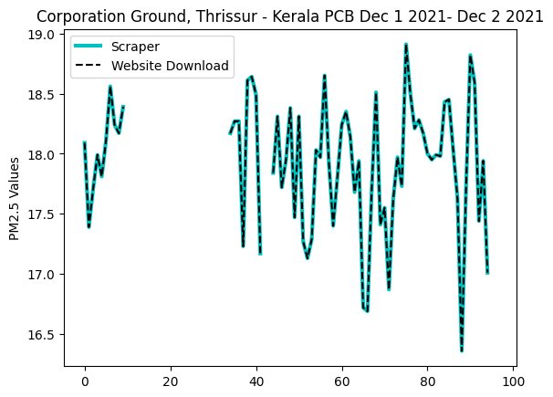

1. Corporation Ground, Thrissur - Kerala PCB (Dec 1st 2022 – Dec 2nd 2022)

Total Values = 24*4+1=97

Total Nans = 27

Exact Match

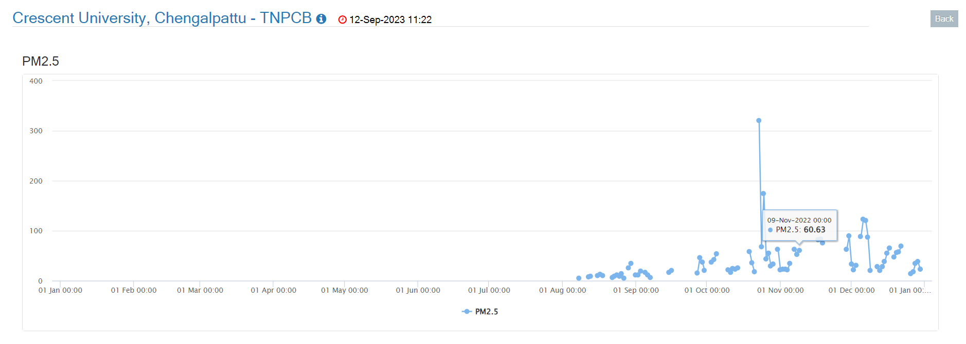Some Stations have too much NaN’s :

Figure 7 Chengalpattu Station : Data at 1 Day Resolution

**Issue With Resolution:** 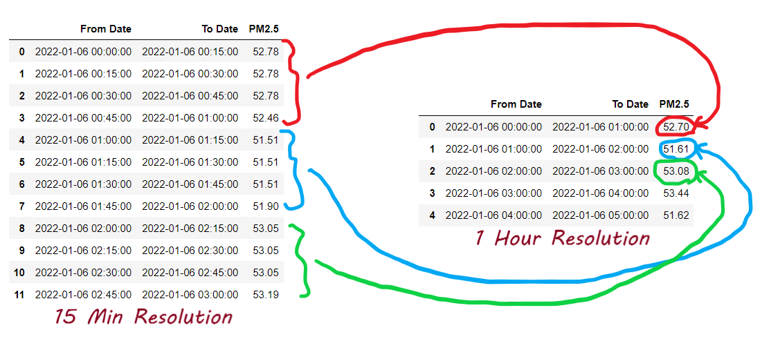

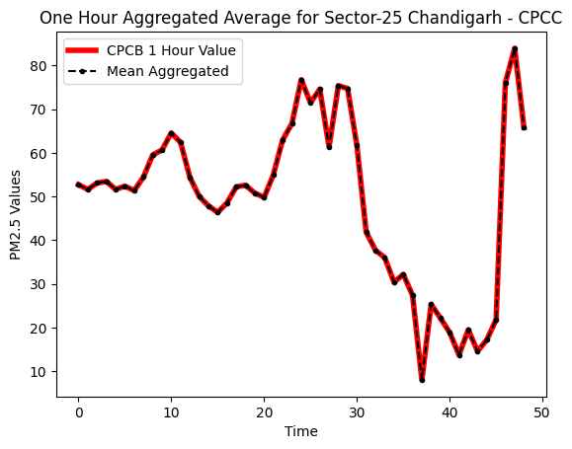

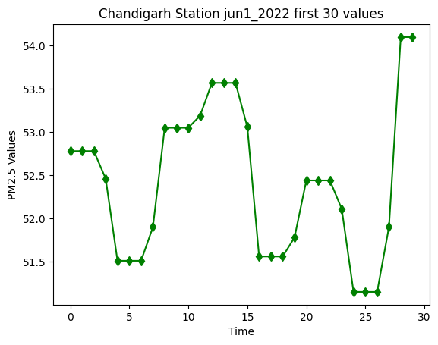

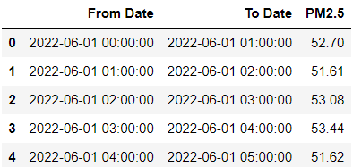

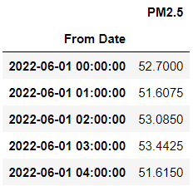

Figure 8: Aggregated Value of PM2.5 using 15 min data

Figure 9: 1 Hour Data Downloaded

Value is measured at 1:00:00 and at 1:15:00 . The 1:15 value used for 1:30 1:45 . Again PM is measured at 2 and 2.15 and 2.15 value is copied until 3:00

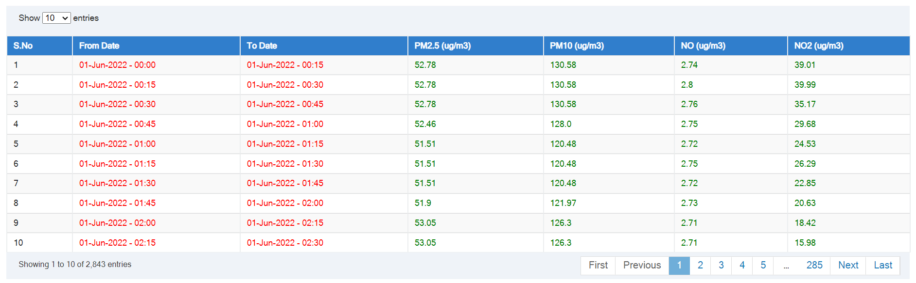**Space Required:**

**Figure 10: 15 min resolution for Chandigarh station from website (To ensure scraper is working well)**

Space for 15 min 1 year data for 1 stations = 631 kb

* 517 stations
* 454 live stations
* 27 Delay
* 36 Inactive

454 stations 5 years = 631 x 5 x 454 =**1.43 GB** Roughly

**AQI in India**

The value ranges between 0 to 500. With 500 being most severe or hazardous.

AQI in India is calculated using 8 Major Pollutants:

1. Particulate Matter: PM2.5 PM10
2. CO
3. O3
4. NO2
5. SO2
6. NH3
7. Pb

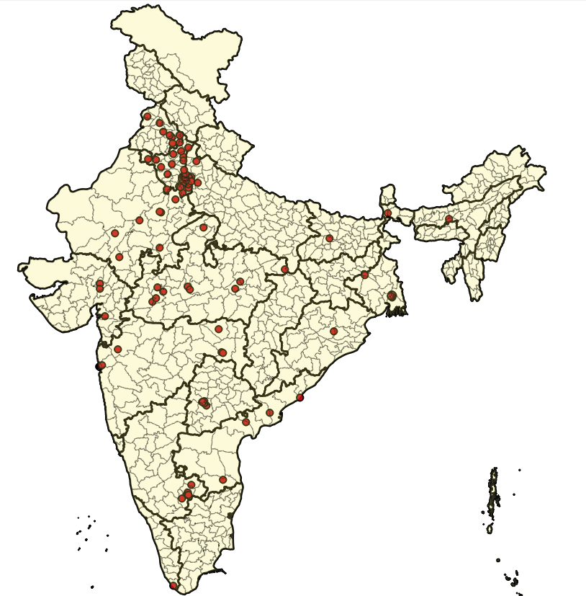

Figure 11: More than 60% data Stations considering: PM2.5 PM10 CO NO2 NH3 O3 SO2 (Pb not available) Count =126

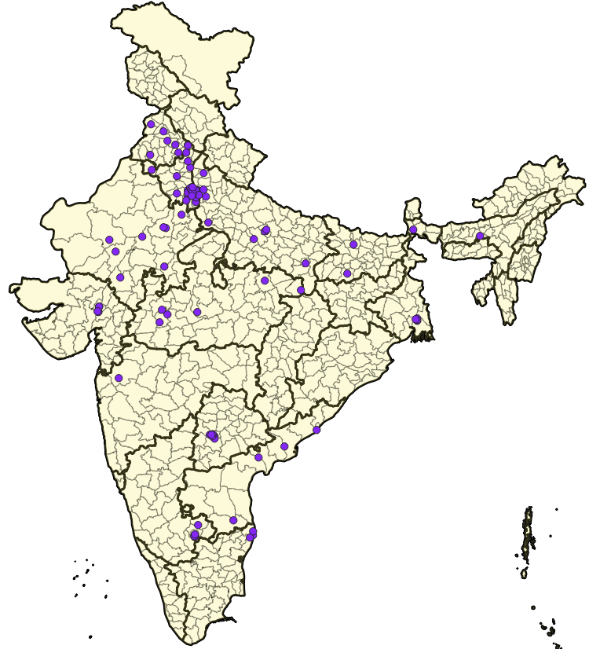

Figure 12: All India PM2.5 with 80 % Fill Rate Use this and apply PCA make suggestion regarding relocating AQ Stations

We need to select stations that have to used for analysis. Why not all station’s?

* Missing values
* Not all parameters are measured at a station

Suggestion to be made :

* Apply PCA and try to identify redundant stations so they can be replaced in another place thereby increasing quality of spatio-temporal AQI map.

How to rank IOT devices on the basis of data quality? What factors are to be considered ? Are there papers this field

How to rank CPCB stations? Which stations to use for analysis?

* Missing Data
  + No of NaN’s in a station
  + If stations A and station B have 5 years data with one day resolution. Both have 365 data values missing . Say Station A has 2013-14 completely missing to a case where station B has only parts of value missing (i.e missing value spread across 5 years). We can give B a better data quality station as we can do some missing data filling using time series models.
* Outlier Station
  + Remove outlier points from stations and use that to reduce score for stations with -ve value or very high value.

**Metric Definition:**

Ran a couple of iterations before finalising a metric. Idea is to give each station a score and **higher score => better the data quality** at the station

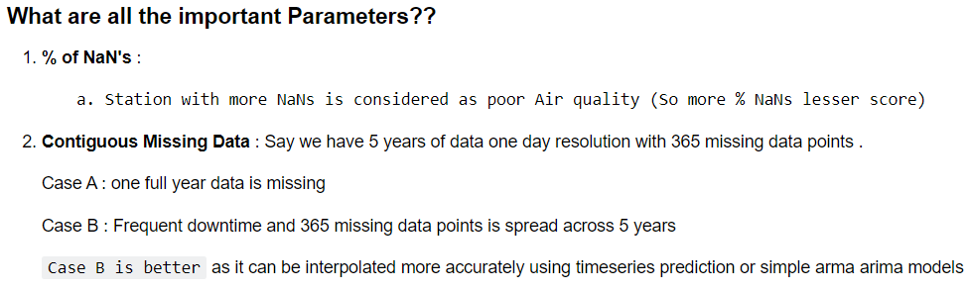

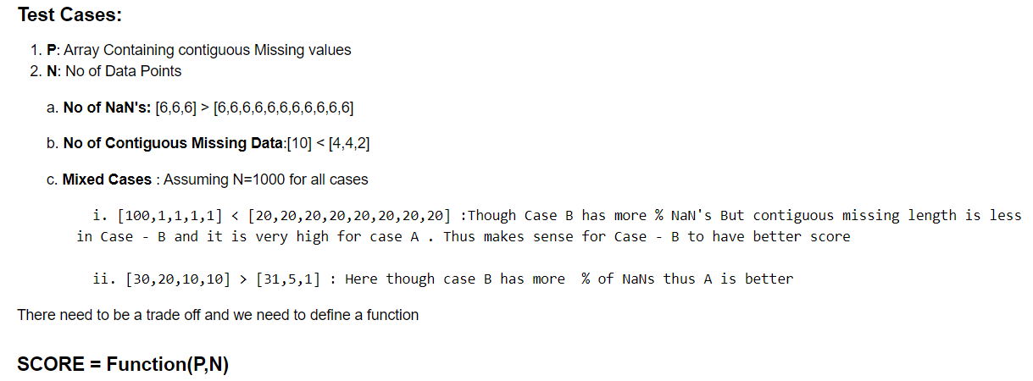

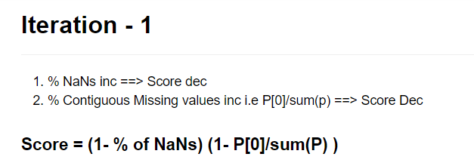

**Case A: [ 6 6 6 ]**

**Case B : [6 6 6 6 6 6]**

Both with N=1000

Ideal Score : Case A > Case B

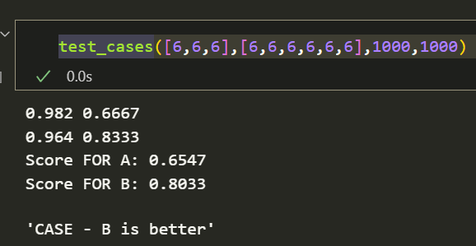But our metric gives case B better score as P[0]/sum(P) is less in case B . Thus using sum(P) as normalising factor for P[0] term fails. Lets correct this in iteration-2.

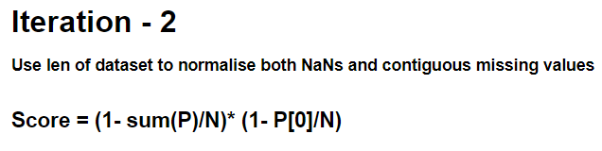Metric seems to working well for most test cases.

But if in our P array P[0] ~ P[1] ~… ~P[K] and so on… then first K terms should be included in term to give it a better score . But finding k for an array P depends on elements in the array especially P[0].

Say we have P1= [100 8 2] ; P2=[10 8 2] In P1 P[1] need not be considered as P1[0] is 100 >> 8 . But in case 2 we can’t ignore 8 as 10 ~ 8. Another example

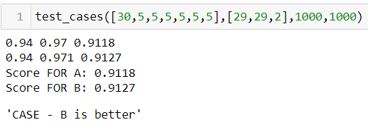**Case A should be better** as we are filling 30 consecutive missing value only once . But in B we have to fill 29 missing values twice . B has better score as we only include P[0] . Thus we have motivation to move to another iteration

**2 Variants**

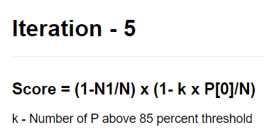

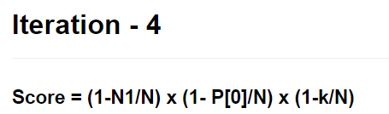

**Iteration 5**

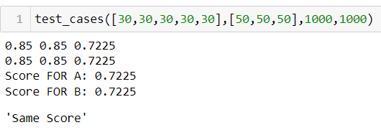Problem occurs in such cases

Iteration 4 solves this problem:

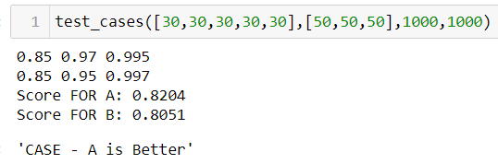

Other cases for iteration 4:

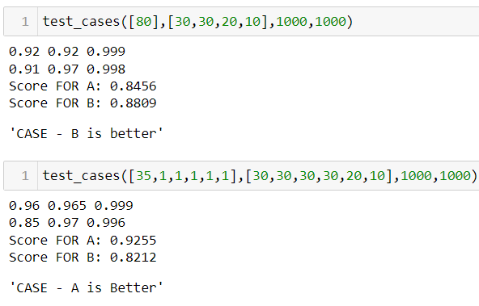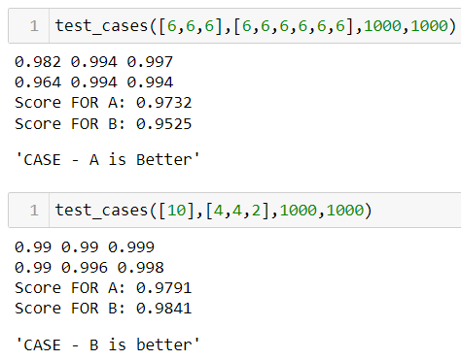

**Final Metric**

K=0.8*p[0]

Any value in range P[0] to P[k] is significant

N1 = Sum(P) # Total Nans



513 stations =====> 441 Stations =====> 200 Stations

R1: Remove stations with any one parameter score = 0

R2: Choose 200 stations with highest score

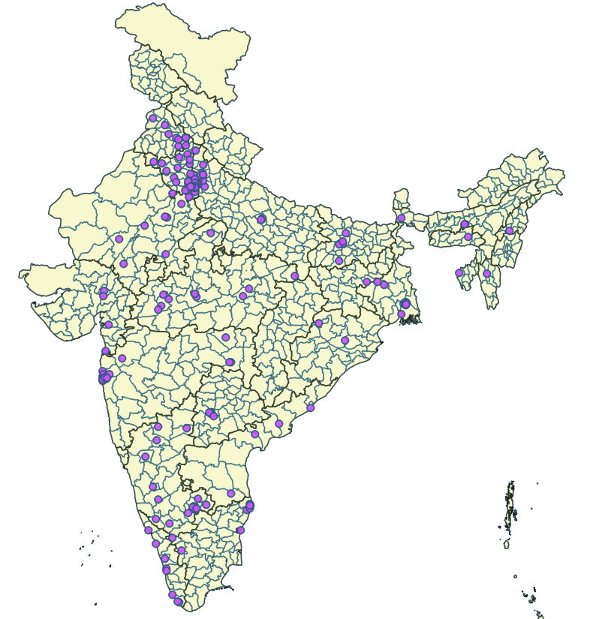

**Figure 13 : Air Pollution Monitoring CPCB Station (200 station with high score)**

**Data Quality Checks**

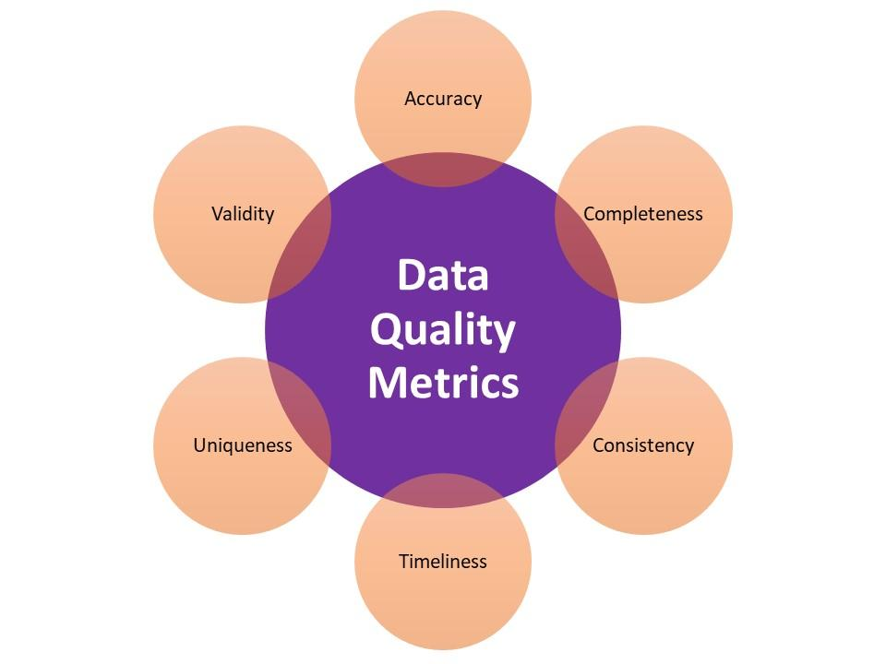

**Data Completeness:**

* + % Nans
  + % Continuous Missing Values

**Accuracy:**

* **Anomaly**: Data not in acceptable range
* **Multi-Column Relationships**: If multi column relationships recorded are same . Eg: PM2.5 and PM10 have correlations and PM10 > P M2.5 always
* **Anomalous Distribution:** Whether distribution in every microsegment is accurate (Ks test might help)

**Uniqueness:**

* Is data sampled every 15min?

**Validity:**

* If sensor has a range and value recorded is out of range then it is invalid data
* Wrong Data Type

**Consistency:**

* Examine consistency in units of measurement, formatting
* Data entered incorrectly or entered in wrong column

**Timeliness:**

* Check if data is up to date required for analysis

**Uses of SCORE:**

* Understanding and Ranking Stations on the basis of score.
* Helps us to calculate aggregates by using score as weights.

**FLOW CHART:**

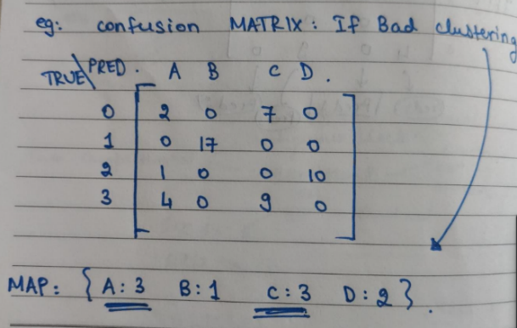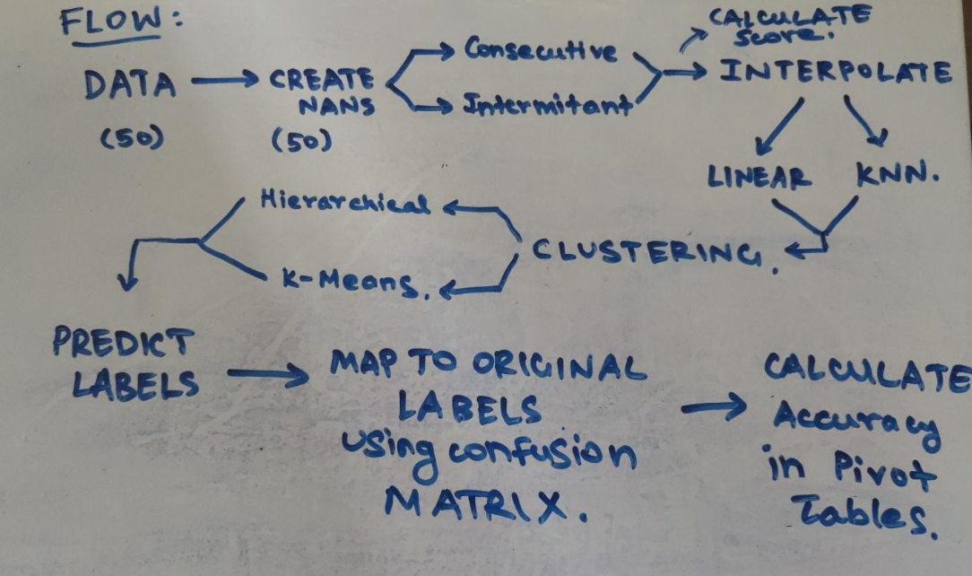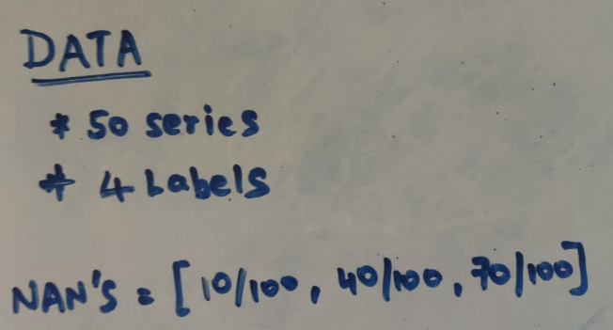For each Nan we create 2 series with both consecutive nans and intermittent nans. So totally 4 series for each nan. Because diff part of series is missing, which can cause variability is clustering. Inc this number is better. But computational difficulty is a concern

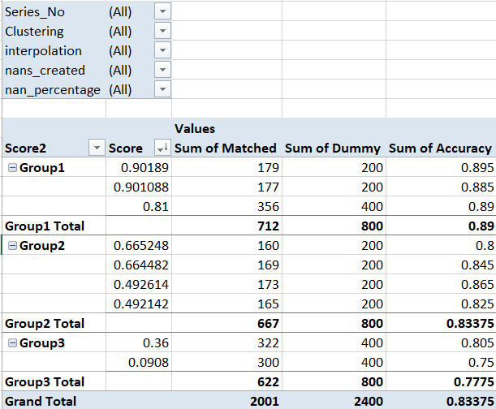**PIVOT TABLE:**

**Figure 14 : General Trend , We can see buckets are of equal volume and as score decreases the accuracy decreases**

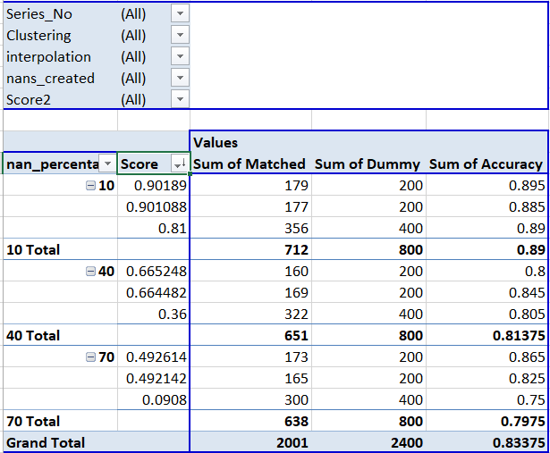

**Figure 15 : Trend with NaN’s and Scores. We can see with 70 % NaN's we have 0.49 and 0.09 as scores and accuracy decreases as score**

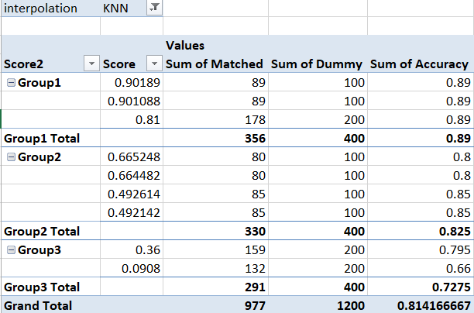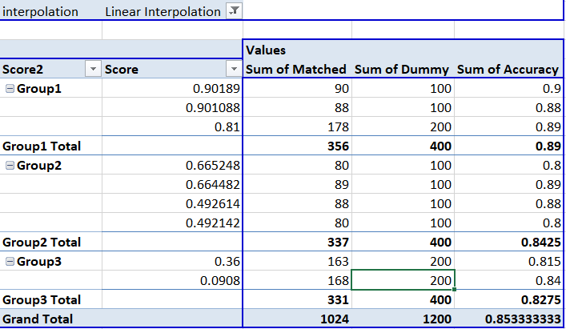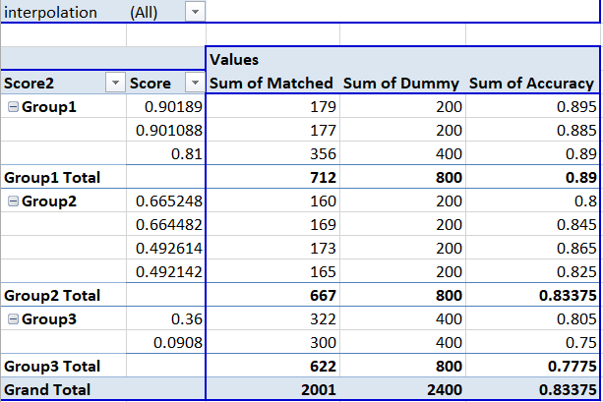

Linear Interpolation seems to work better. More data points required to come to a conclusion

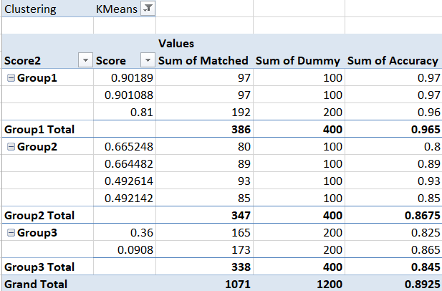

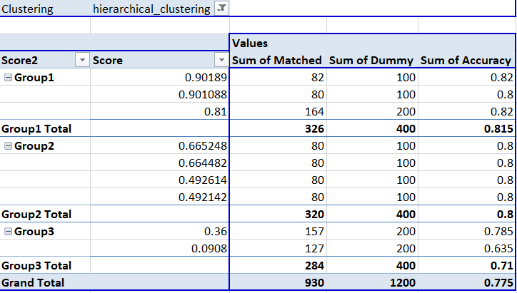

K Means Clustering seems to work better

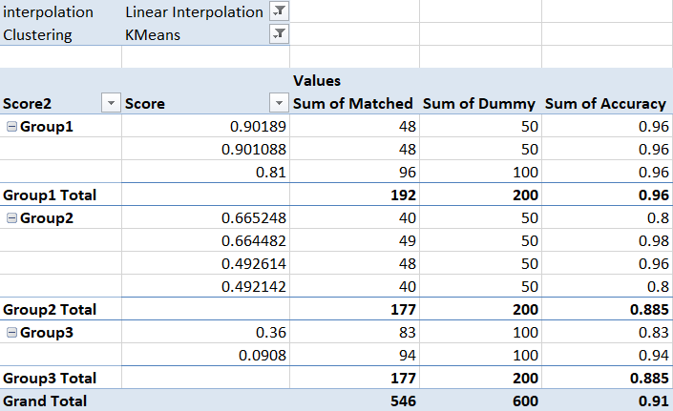

**Figure 16 : Best Results**

Running in server:

* Runs for different datasets (same Trends try changing seasonality patterns)
* Try for more variations of dataset generated with same NaN’s
* Try for a lot of null percentages

**Data Required:**

1. [PM2.5](https://sites.wustl.edu/acag/datasets/surface-pm2-5/) (1980-2021) every 0.05o ~ 6 km
2. Population

* For 2011: (EXCEL)
  + Population: (Male vs Female)
  + Literacy Rates for men and women
  + Primary Middle or Higher Education

1. Geographical Data
   1. Altitude : Website have data given coordinates . Need web scraping. (Very essential)
   2. Is [Costal Region](https://iomenvis.nic.in/index3.aspx?sslid=14748&subsublinkid=606&langid=1&mid=1)? (66 costal regions)
   3. [Total Area](http://www.statoids.com/yin.html)
2. Land Use Patterns
3. Economic Factors
   1. GDP available state-wise

**Paper 6 : Identification of Redundant Air Quality Monitoring Stations using Robust Principal Component Analysis**

* Greater Vitoria Region in Brazil
* Has 8 stations (only using PM10 Data for analysis)
* Jan 2005 to Dec 2009 (5 years)
* 4 stations enough to explain 80% variability, install redundant stations in other parts to increase air quality measurement
* Apply PCA to remove Redundant stations
* Outliers : They affect mean and variance and thus affect the correlation or the covariance matrix . Wide range of practitioners drop these outliers. But this deletion is very subjective decision.

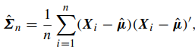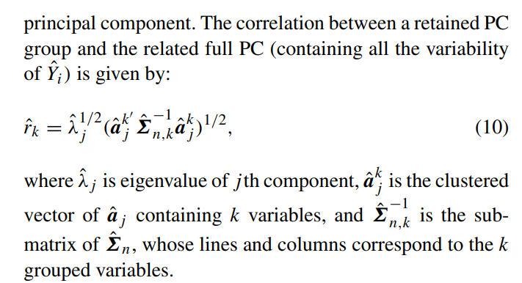

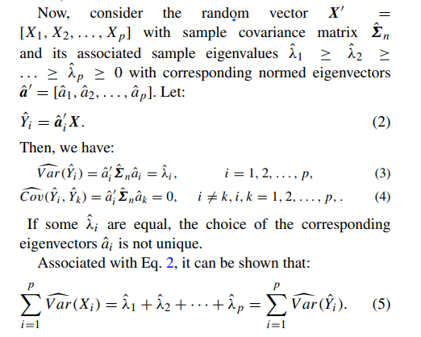



Steps :

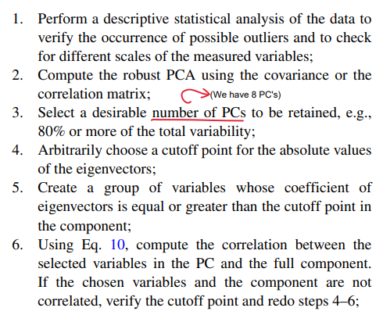

[**Paper 5**](https://ieeexplore.ieee.org/abstract/document/4680723)**: Time Series Clustering Based on ICA for Stock Data Analysis**

**Stock Price(30x200)=Mixing Matrix (30x5) *Sources(5x200)**

**Cluster using Mixing Matrix**

* Timeseries clustering has broadly 2 strategies:
  + Raw Data based approach
  + Feature based approach
* Lets take 30x200 matrix with 30 stocks and closing price for 200 days
* We try to extract a features from each stock assuming it is a summation of 5 independent components.
* Each stock will a weighted sum of these independent components and using the weights matrix we can cluster these stocks
* Used k=4 and got stocks with similar trend

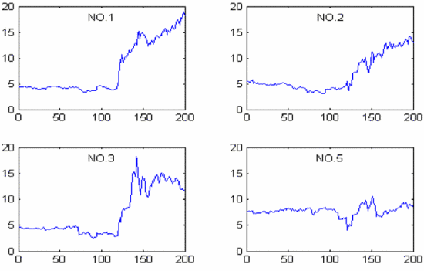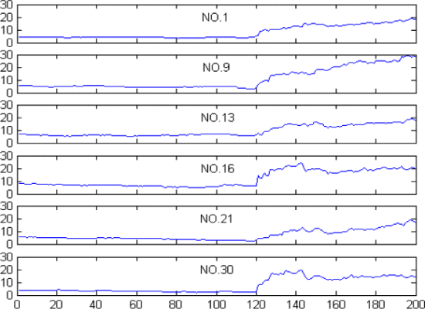

Figure 17: Stocks belonging to different cluster

Figure 18: All stocks belonging to cluster 1

LHS : No1 No 9 means stock number that belong to same cluster

RHS : No 1 No 2 means stock number but all of them belong to different cluster



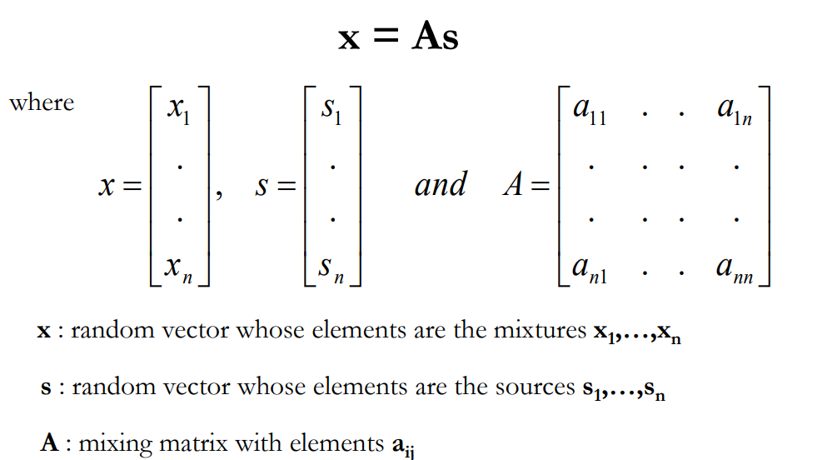

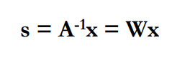

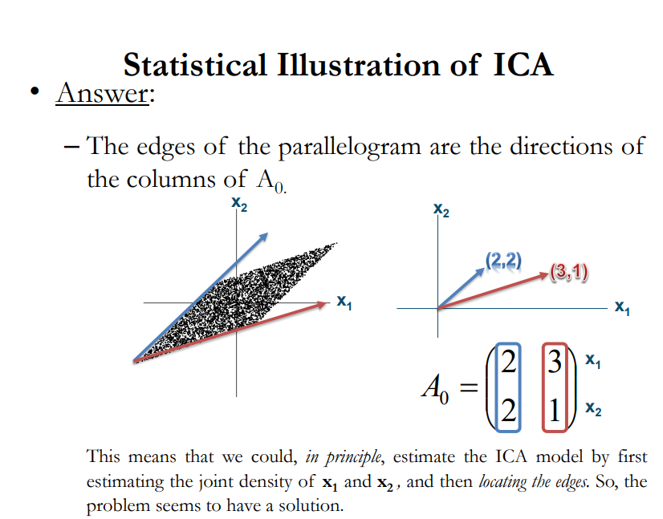

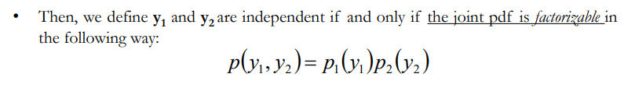

**Assumption of ICA : Non Gaussian Distribution Why??**

